MSIL is the lowest level .NET language. All languages targeting .NET framework generate MSIL. As a C# developer, you will probably never write MSIL code directly, but you will often look at the MSIL disassembly of your application for answers to dependency, versioning and optimization questions.
To start disassembling C# (or any other .NET application) you need to run ildasm.exe from either VS.NET command prompt or .NET framework command prompt. On my computer, ildasm.exe is at C:\Program Files\Microsoft Visual Studio 8\SDK\v2.0\Bin.
Where does the term boxing come from? Is there such a keyword in C#? What about VB.NET? Why do we call value to object conversion boxing and the opposite conversion unboxing? Because, MSIL is using box and unbox keywords to perform these conversations.
So, let's study MSIL. The simplest MSIL program is the one which does not do anything and has no data:
.assembly hello{}
.class hello
{
.method static public void main() il managed
{
.entrypoint
ret
}
}
MSIL is an object oriented assembly language. As such, it retains object-oriented constructs of the source languages e.g., private and public methods. Every MSIL application needs to have an entry point. Any method (not just Main) can serve as the entry point as long as it is decorated with .entrypoint instruction. MSIL programs are compiled with the Intermediate language compiler, ilasm.exe that is located in the same directory as the disassembler. Here is a more complicated program that, once again, does not do anything but has some data.
.assembly hello{}
.class hello{
.method static public void main() il managed{
.entrypoint
.locals( string V_0)
ldstr "hi there"
stloc.0
ret
}
}
Types of JIT:
Pre-JIT compiles the complete source code into native code in a single compilation cycle. Normally it is done at the time of deployment.
Econo JIT compiles only those methods called at runtime. The compiled code is removed when not required.
“Normal” JIT compiles only those methods called at runtime. The methods are compiled the first time they are called and then stored in cache. When the same methods are called again, the compiled code from cache is used for execution.

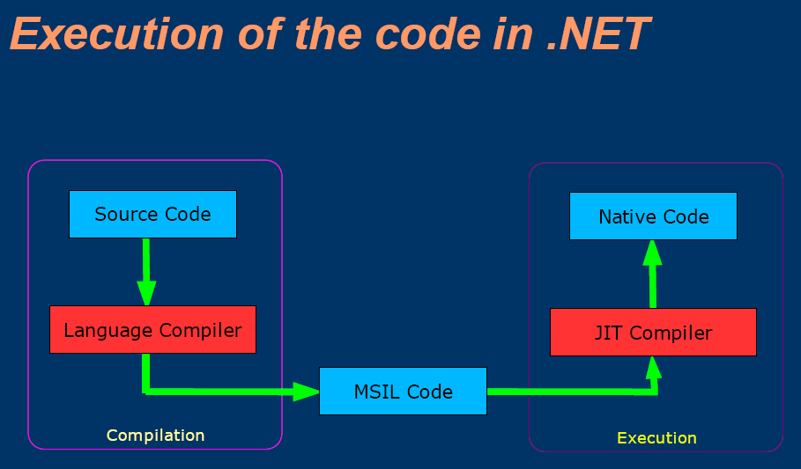

Compiling IL To Native

- Pre-JIT
  - Done at installation time
  - Reduces start-up time

- “Econo” JIT
  - Generates unoptimized native code
  - Code can be discarded and regenerated

- “Standard” JIT
  - Generates optimized native code
  - Includes verification of IL code
  - Native code has version checks and reverts
to runtime JIT if they fail

